The Holy Seed
The holy seed is a chosen seedling that is growing rapid like an arrow in a soldiers hand, happy is the man who has many such arrows. He will not be defeated when he meets his enemies in the place of judgment.
Happy are those who by the Lord, who live by his commands, your work will provide for your needs you will be happy and prosperous, your wife will be like a fruitful vine in your home and your children will be like young olive trees round your table. A man who obeys the lord will surely be blessed like see Jerusalem prosper all the days of your life! May you live to see your grandchildren making a global peace be with Israel you cant miss to join us!
Listen while I sing you this song, a song of my friend and this vineyard, my friend had a vineyard on a very fertile hill. He dug the soil and cleared it of stones, he planted the finest vines. He built a tower to guard them, dug a pit for treading the grapes he wait for the grapes to ripen, but every grape was sour.

The holy seed is germinated to a seedling that has grown to give a ripen grapes is I and you. But we are not giving good grapes instead we are giving sour grapes why? Because we are not taking care of those who are in needs. Look the widow who is sitting under your table asking for your help and you don’t. The orphans stranding at your feed holding your clothes crying for your help but you don’t beside you, you have your brothers and sister who need your help but you are not helping them. How can you say that we are going to heaven while we have division among ourselves? Every person has been given talent from God and motives to perform his duties, being a leader in the government or pastor in the church. We have to give respect to each other according to hos talent the way he present his views, because we are building up the government and churches to have a global peace. Because in heaven we have only one table that we are going to sit after crises is over. Because we are going to be saved by Jesus Christ himself, so he will not save two groups so only the chosen holy seed will prosper.

Now I beseech you brethren by the name of our Lord Jesus Christ hat yee all speak the seem thing and that there be no division among you, but the ye be perfectly doing together in the same mind and in same judgment, knowing that the son of God is at than to harvest I and you as a holy seed. (1 Corinthians 1:10-31)

May God bless you to keep your promise Ecclesiastes 5:1-7

I will appreciate for your comments.

The Holy Seed
In the beginning God created the heaven and the earth, and above the firmament that was over their heads was the likeness of a throne as the appearance of a sapphire stone: and upon the likeness of the throne was the likeness as the appearance of a man above upon it.
And I saw as the color of another as the appearance of fire round about within it, form the appearance of his doing even upward and form the appearance of his doing even downward, I saw it were the appearance of fire and it had brightness round about. As the appearance of the bow that is in the cloud in the day of rain so was the appearance of the brightness round about. This was the appearance of the likeness of the glory of the Lord, and when I saw it I fell upon my face and I heard a voice if one that spake.
Them hath he filled with wisdom of health to work all manner of work of the engraver, in blue, and in purpose in scalet and in fine linen and other weaver even of them that do any work and of those that devise cunning work. Then wought Bezaleel and Aholiah, and every wise hared ma, in whom the Lord put wisdom and understanding to know how to work all manner of work for the service of the sanctuary according to all that the Lord had commanded.
Come now, and let se reason together, saith the Lord: through your sins be as scarlet, they shall they shall be as wool if he be willing and obedient , ye shall eat the good of the land: The Lord is my shepherd: I shall not want. He maketh me to lie down in green pastures: he leadeth me beside the still paths waters. He restored my soul: he lendth me in the paths of righteousness for his names sake. Yea, though I walk through he valley of the shadow of death I will fear no evil for thou art with me, they rod and thy staff they comfort me. Thou prepares a table before me in the presence of mine enemies thou anoints my head with oil, my cup runneth over, surely goodness and mercy shall follow me all the days of my life: and I will dwell in the house of the Lord for ever.
Every word of God is pure: he is a shield unto them that put their trust in him . Add thou not unto his words lest he reprove thee and thou every word of God is pure he is a shield unto them that put their trust in him. And thou not unto his words, lest he reprove thee, and those be found in liar two things have I required of thee deny me them not before I die: Remove me far from vanity and lies give me neither poverty nor riches; feed me with food convenient for me: Lest I be full and deny thee and say, who is the Lord? Or lest I be poor and steal and take the name of my God in vain.
Let us labor therefore to enter into that rest lest any man fall after the same example of unbelief for the word of God is quick and powerful and sharper than any two edged sword, piercing event the diving a sunder of soul and spirit and of the joints and marrow and is a discerner of the thoughts and intents of the heart.
Neither is there any creature that is not manifest in his sight: But all things are naked and opened unto the eyes of him whom we have and it shall come to pass afterward, that I will pour out my spirit upon al flesh and your sons and your daughters shall prophesy, your old men shall dream dreams, your young men shall see visions, and also upon servants and upon the handmaids in those days will I pour out my spirit and I will show wonders in the heavens and into earths, blood, and five and pillars of smoke. The sun shall be turned into darkness and the moon into blood , before the great and the terrible day of the Lord came and it shall come to pass that whosoever shall call on the name of the Lord shall be delivered: for n mount Zion and in Jerusalem shall be deliverance as the lord hath said.
The Holy seed

Now the word of the Lord came unto Jonah the son of A-mit-tail saying, Arise go to Nini-e-veh that great city and cry against it for their wickedness is come up before me…..then the men feared the Lord exceedingly and offered a sacrifice unto the lord and ,made vows now the Lord had prepared a great fish to swallow up Jonah. And John was in the belly of the fish three days and three night … and the Lord space unto the fish and it vomited out Jonah upon the dry land and the word of the lord came unto Jonah saying the second time saying go and preach unto it the preaching that I bid thee……..and he cried and said, yet forty days Nin-e-veh shall be overthrown so the people of Nin-e-veh believed god and proclaimed a fast and put on sackcloth, form the greatest of them even the King of Niv-e-neh and he arose from his throne and he laid his robe form him and covered him with sackcloth and sat in sales and he caused it to be proclaimed and publishes through Nineveh by the decree of the king and his nobles, saying let neither man or beast, herd nor flock taste anything; let them not feed, nor drink water who can feel if God will turn and repent, and turn away form his fierce angers that we perish not? And God saw their works that they turned from their evil way, and God repented of the evil that he had said:- that he would do unto them; and he did it not so Ni-e-veh was saved from distraction.
And they shall bring the glory and honour of the nation into it and there shall in no wise enter into it anything that delifth, neither whatsoever worketh abomination or maketh a lie but they which are written in the lamb’s book if life and he showed me a pure river if water of life clear as crystal, proceeding out of the throne of God and of this lamb: In the midst of the street of it and on either side of the river was there the tree of life which bare twelve manner of fruits and yielded her fruit every month and the leaved for the tree were for the healing of the nations.

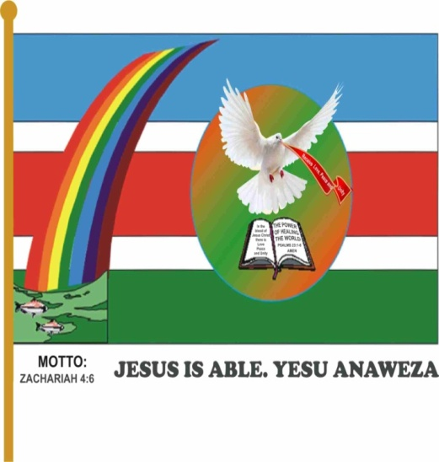

Definition of the Parts of the Flag
1. Sky Blue - Heavenly kingdom and mercy of God
2. Red - The Holy Spirit and blood of Jesus Christ
3. White - Holiness of God and peace to all creations
4. Green - A promise land and the new Jerusalem
5. Water - The living water
6. The Dove - The gospel to the gentiles
7. Gold - The kingdom (Church)
8. Rainbow - The seal of God
9. The Fish – Transport and Revelation of Christ
