KIDS
IN THE BEGINNING
LESSON: GOD IS A CREATOR
In the beginning God created* the heaven and the earth. And the earth was without form, and void; and darkness was all over. 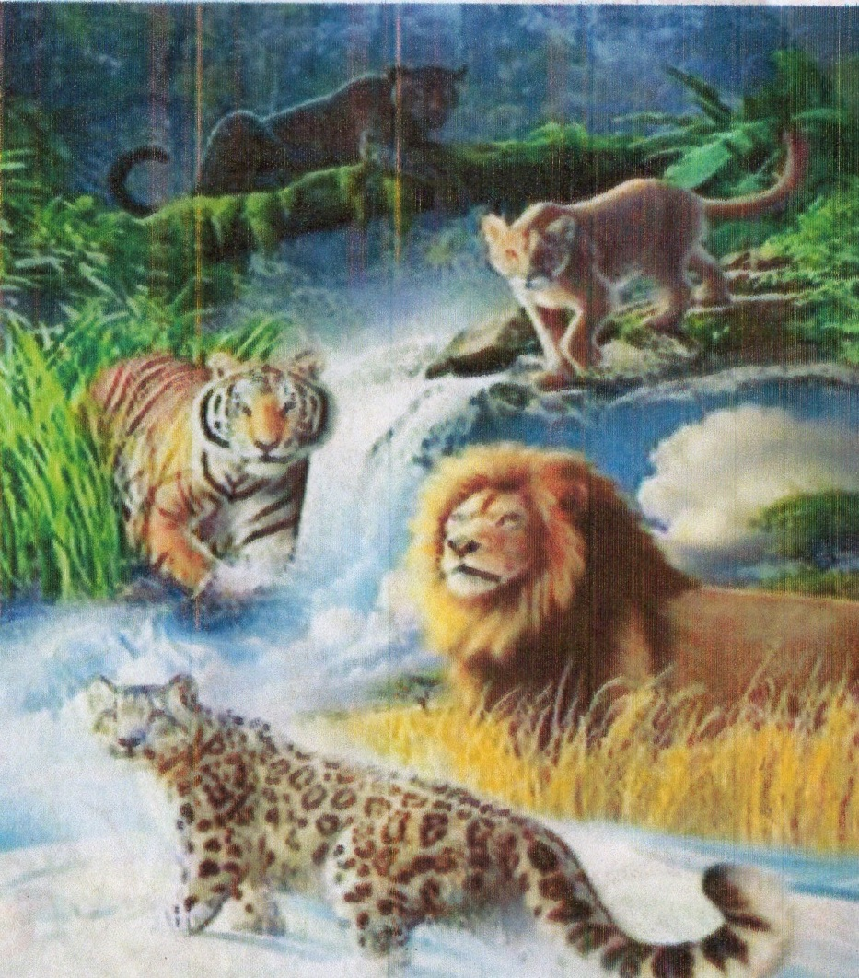And the Spirit of God moved upon the face of the waters. God by his word made the sun, the moon and the stars. All plants and animals that we see were made by word. Genesis 1:1-25
THE FIRST PEOPLE
Lesson: We enjoy blessings when we obey God’s word
The first people in God’s creation were Adam and his wife Eve. 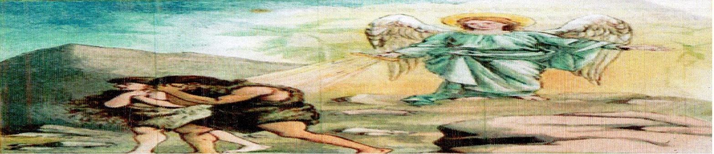They live happily in the Garden of Eden whenever they obeyed God’s word. However they later disobeyed God and they were driven out of the happy Eden. Genesis 2:7-25, 3
CAIN AND ABEL
Lesson: God only accepts offerings made in his provided way
Abel was a keeper of sheep but Cain worked in the field. They both brought an offering to God. 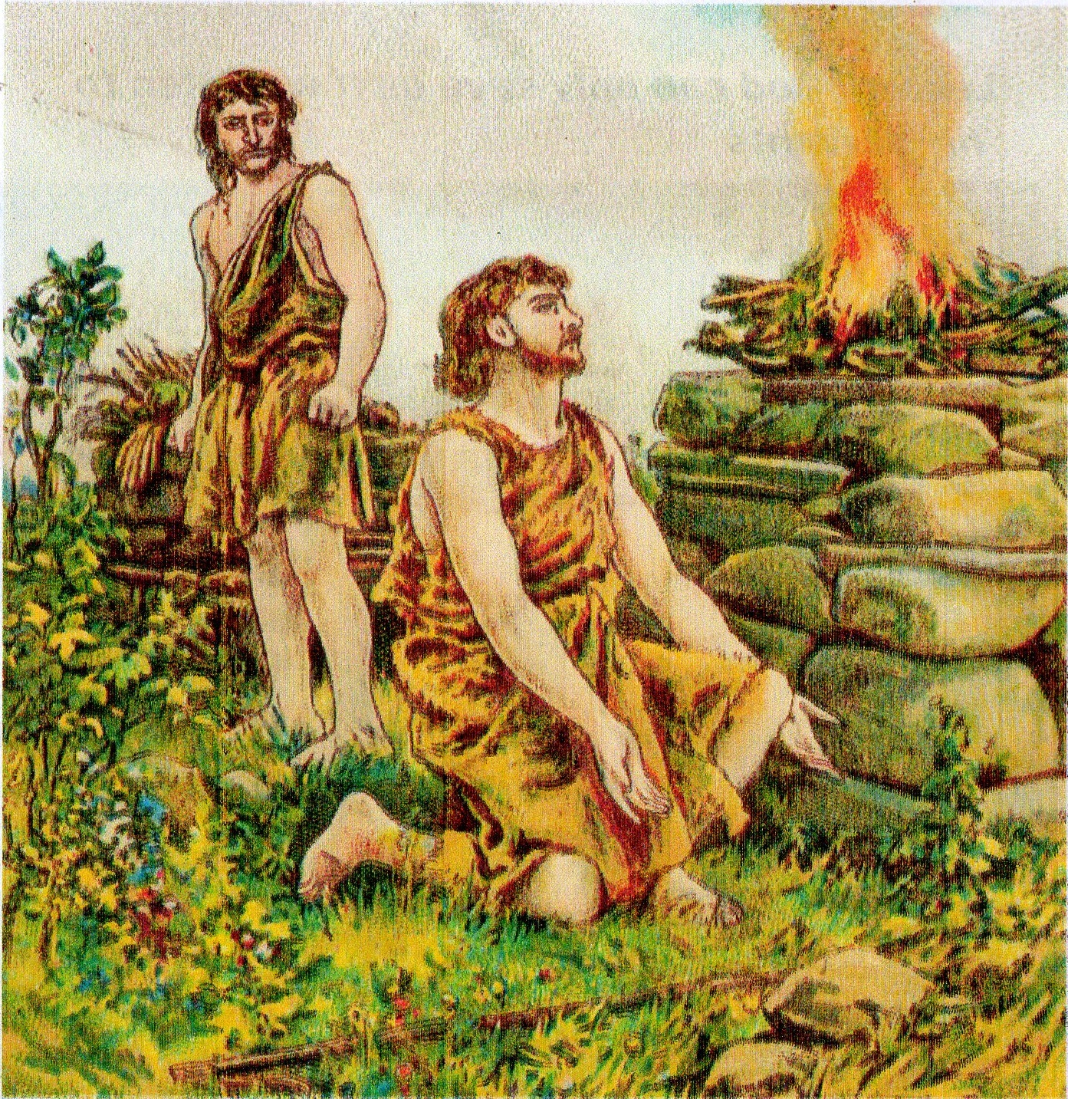 Abel offered a sheep from his flock while Cain offered to God fruit from the field. Abel’s offering was accepted but Cain’s rejected. Genesis 4:1-5
NOAH AND THE ARK
Lesson: God can only save us if we listen to his servants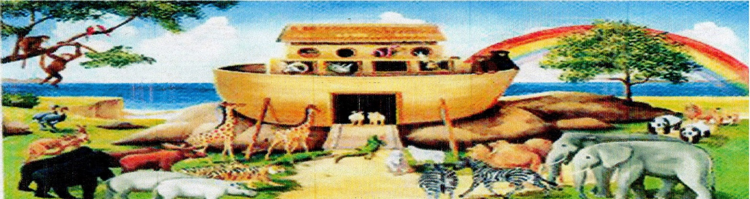
The people of the world became wicked and God was very angry, regretting why he made man.
 God directed Noah to build a special big boat which was called the Ark. God then sent rain and there was a great flood as never seen from the beginning of the world. The earth was destroyed but Goo saved Noah his family and animals in the Ark. Genesis 6:7-22, 7:1-23
THE TOWER OF BABEL
Lesson: we can only reach God through prayer
The whole earth was of one language, and of one speech. 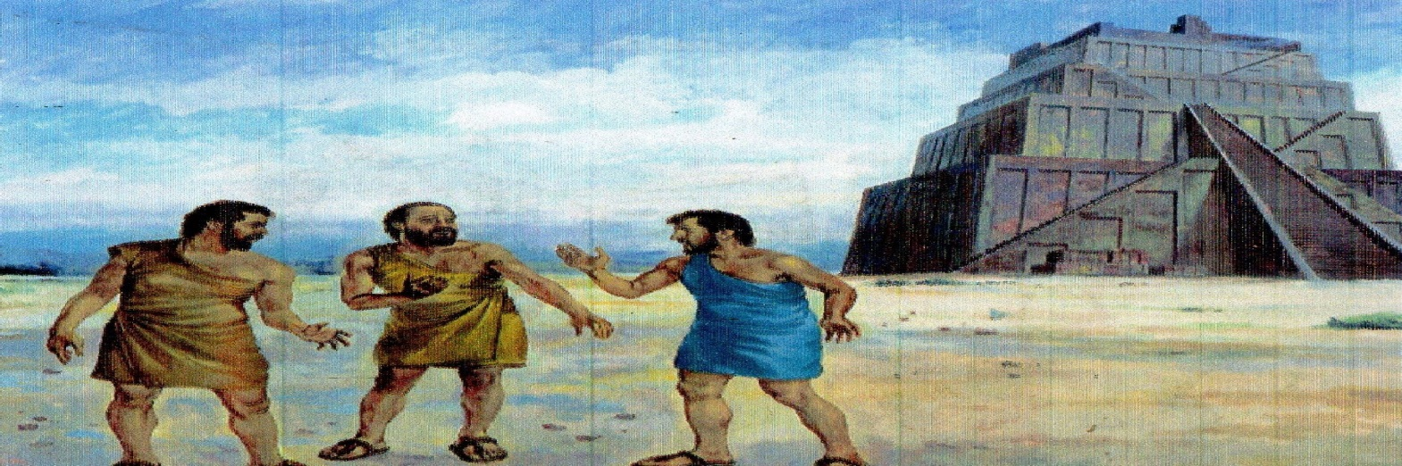Then the people decided to build a tall tower to reach heaven. However God was not pleased with their idea and so he went down and confused their speeches so that none could understand the other.
He then scattered them across the world and the tower was not completed. Genesis 11:1-9
ABRAHAM AND ISAAC
Lesson: we can’t places God without faith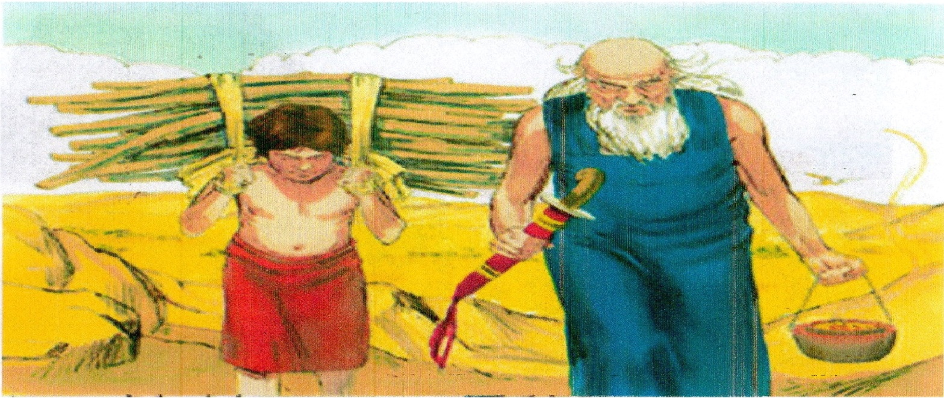Abraham is our Father of Father. His wife was Sarah.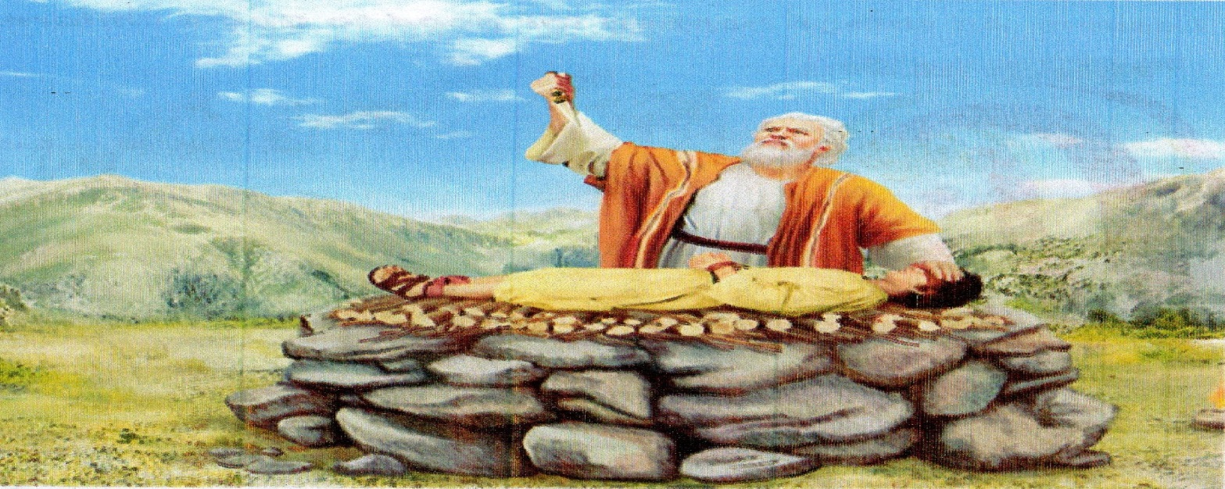God gave him a miraculous son named Isaac when he was 100 years old.
God tempted Abraham’s faith by telling him to offer Isaac for a sacrifice. He obeyed, but just when he was about to kill his only son, God provided a lamb for sacrifice. He was happy for his obedience. Genesis 21:1-7, 22:1-19
JOSEPH RULES IN EGYPT
Lesson: All thing happen for good to God’s child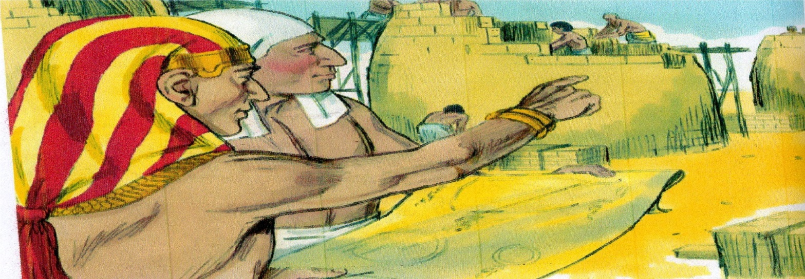
Joseph was the Son of Jacob. He was sold by his brothers to Egypt to become a slave.
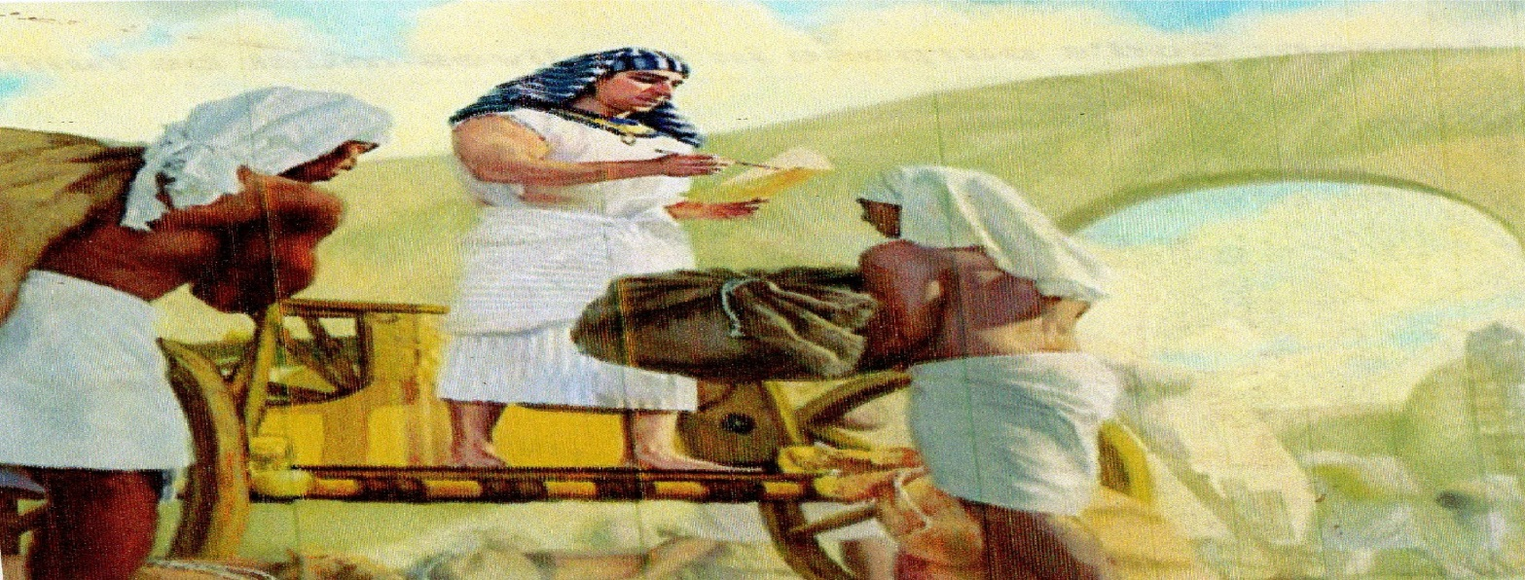However God prospered him and he was made the ruler of Egypt by pharaoh.
Egypt became a great nation with plenty of food under Joseph’s reign. Genesis 41:40-57
BABY MOSES
Lesson: God’s purpose in our lives in our lives must be foodie 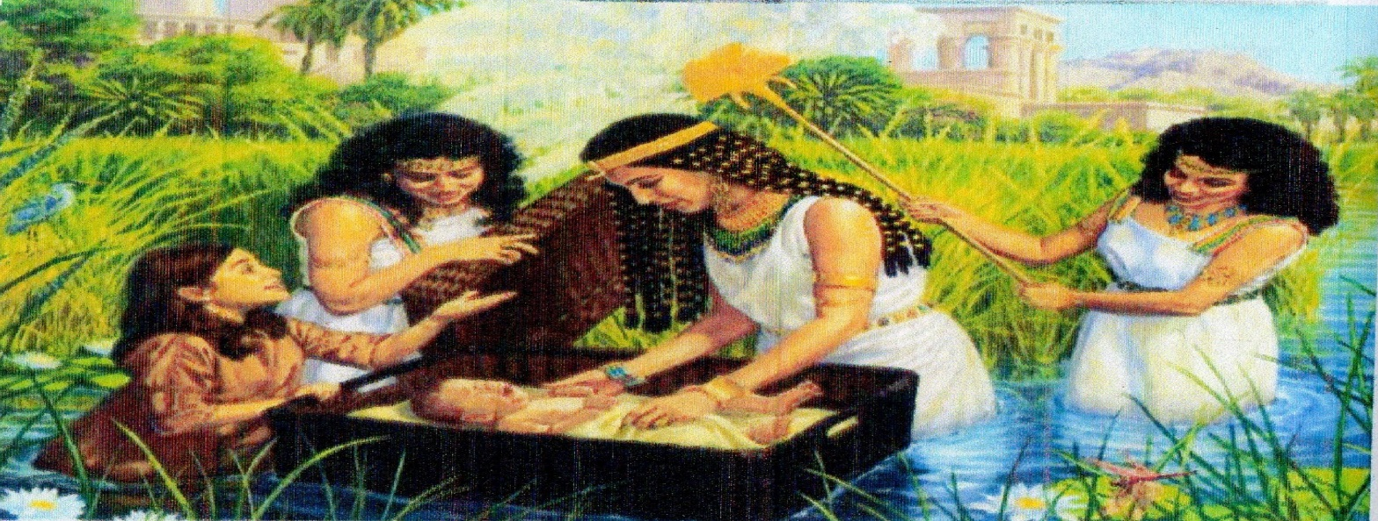
Mosses born to deliver thechildre children when he was burned am hid these made a baskets with she put him and placed him at river
This was because the king wanted all the Israelite’s baby boys to be killed. God later used Moses to leads his people out of bondage. Exodus 2:1-10
MOSES AND THE BURNING BUSH
Lesson: God remembers his promise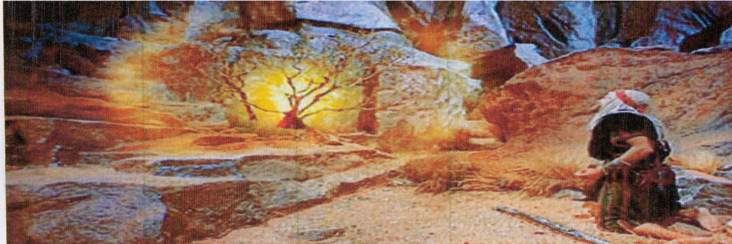
Moses was rearing sheep. He saw a bush which was burning without being consumed by fire.
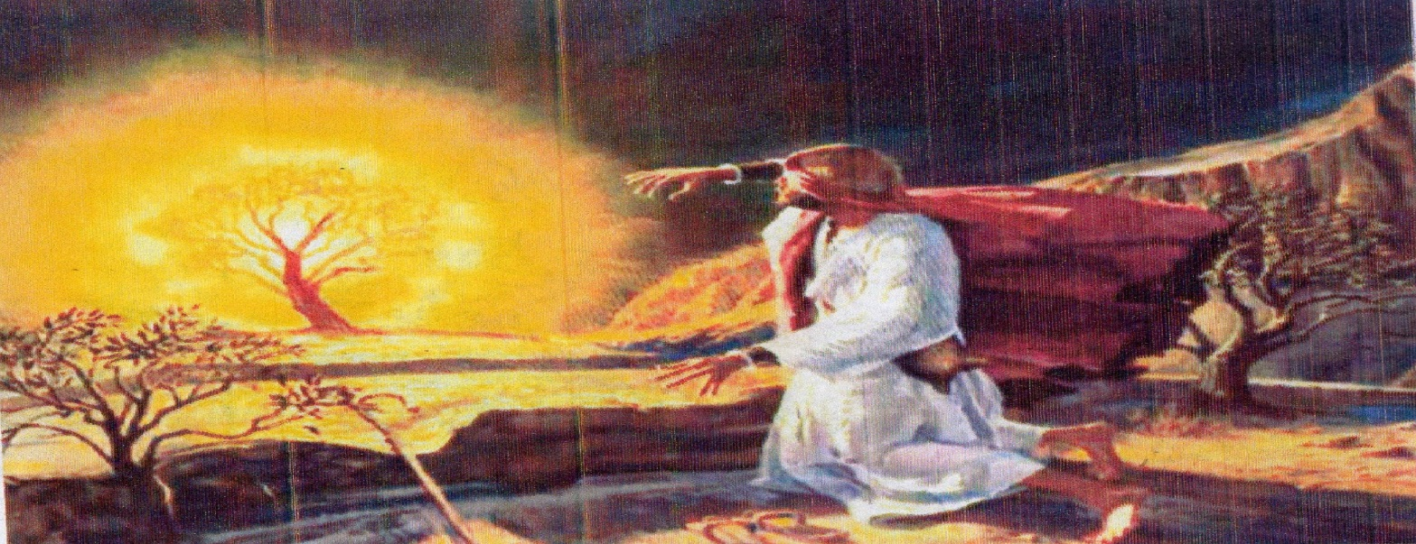God talked to Moses from the burning bush and commissioned him to go and deliver Israelites from pharaoh’s slavery in Egypt. Exodus 3, 4:1-17
THE RED SEA
Lesson: God is able to deliver us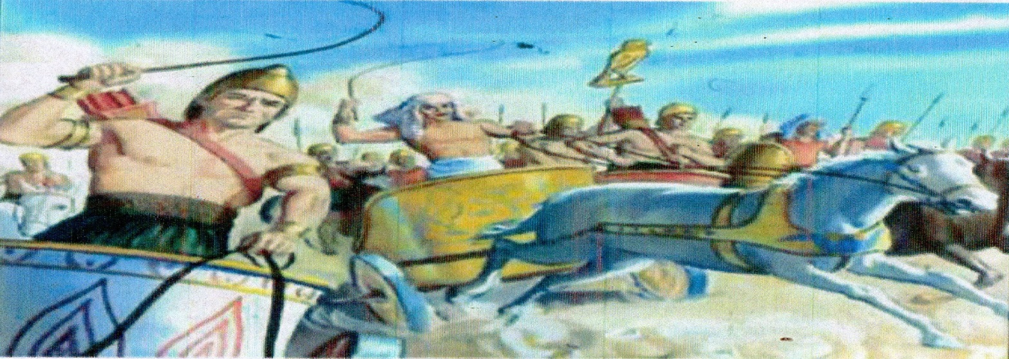
After the children of Israel were delivered from Egypt, they came to the red sea on their way, land to promised land, Canaan.
Pharaoh and his army were after them to capture them again.
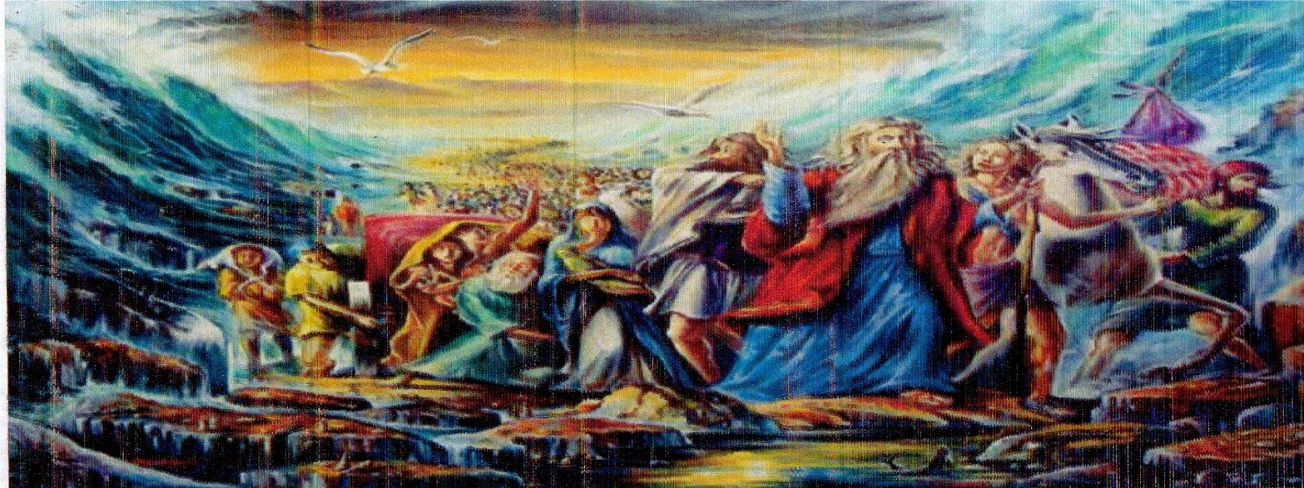God parted the waters of the red sea and there was a dry way in the middle of the sea.
They crossed safely to the other side but pharaoh’s army was desired in the sea. Exodus 14:8-31
JOSHUA PRAYS FOR THE SUM TO STAND STILL
Lesson: God is a present help in time of trouble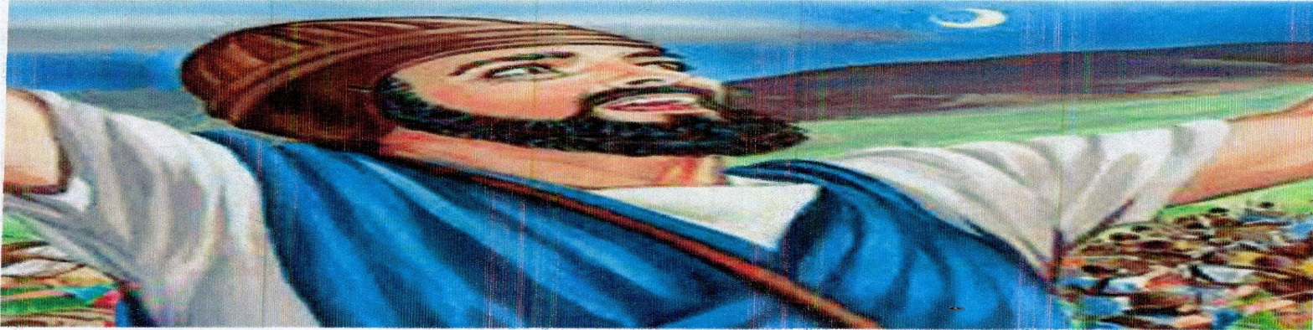
Joshua was leading the Israelites to battle. It got late in the day before they could win the battle.
Joshua prayed for more daylight to win the battle.
He commanded the sum to stand and it stood still until the battle was won against their enemies. Joshua 10:12-14
THE STORY OF SAMSON
Lesson: God can use us in unusual way for his glory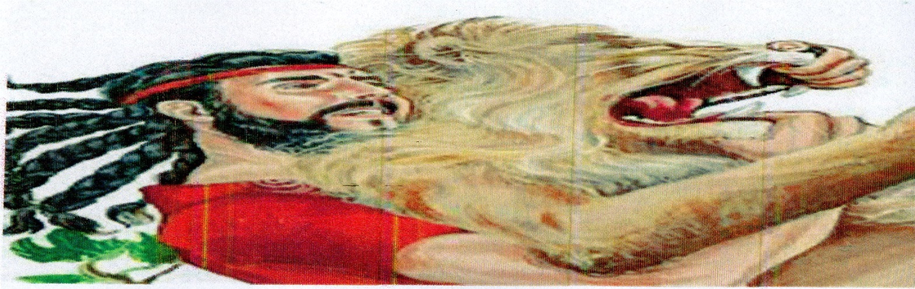
Samson was given supernatural strength by God. The strength was in his long hair.
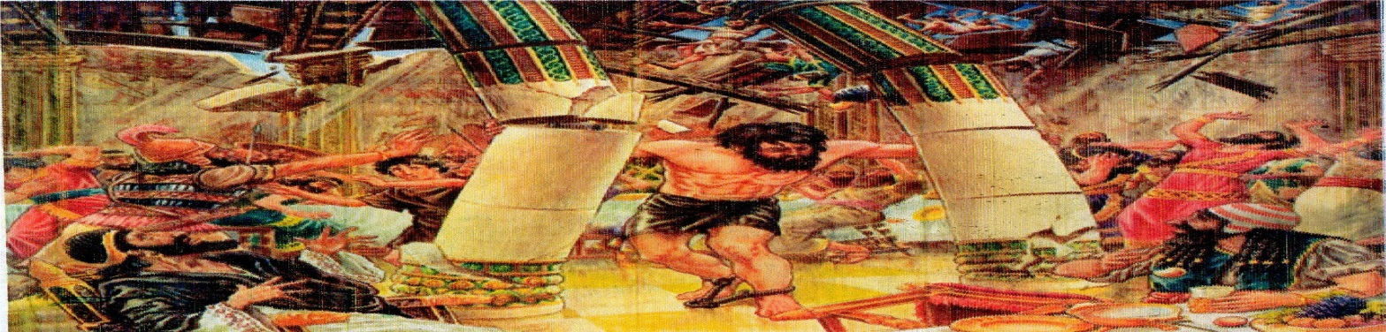He was able to fight his enemies and perform heroic acts such as killing a lion with his hands, slaying an entire army with only a jawbone of a donkey, and destroying a pagan temple. Judges 13:16
THE STORY OF RUTH
Lesson: Determination pas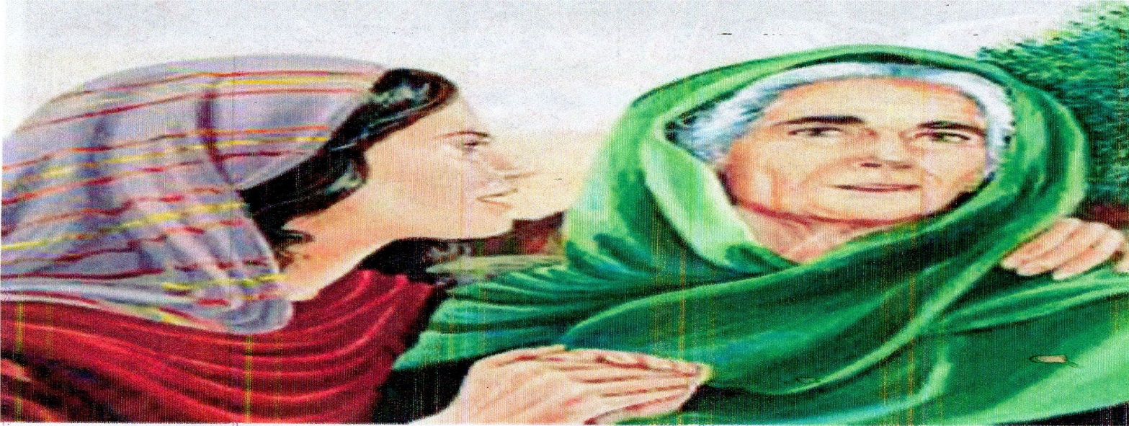
When famine hit Bethlehem, Elimelek and Naomi took their two sons, Marlon and Chilton to live in Moab. One of their sons married Ruth, a Moabite. 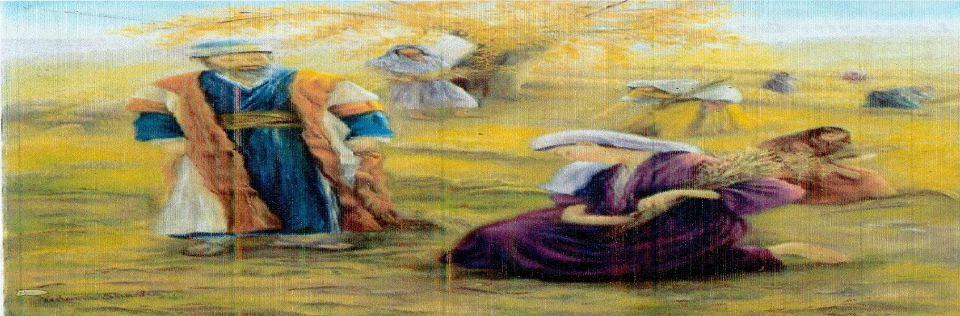
Naomi’s sons died and she died she decided to go back to Bethlehem. Ruth vowed to go with Naomi. On returning to Bethlehem, Ruth went to work in the fields of Boaz who protected and provided for her. Boaz took the responsibility of a kinsman redeemer and married Ruth. Ruth 1-4
GOD SPEAKS TO YOUNG SAMUEL
Lesson: God can talk to children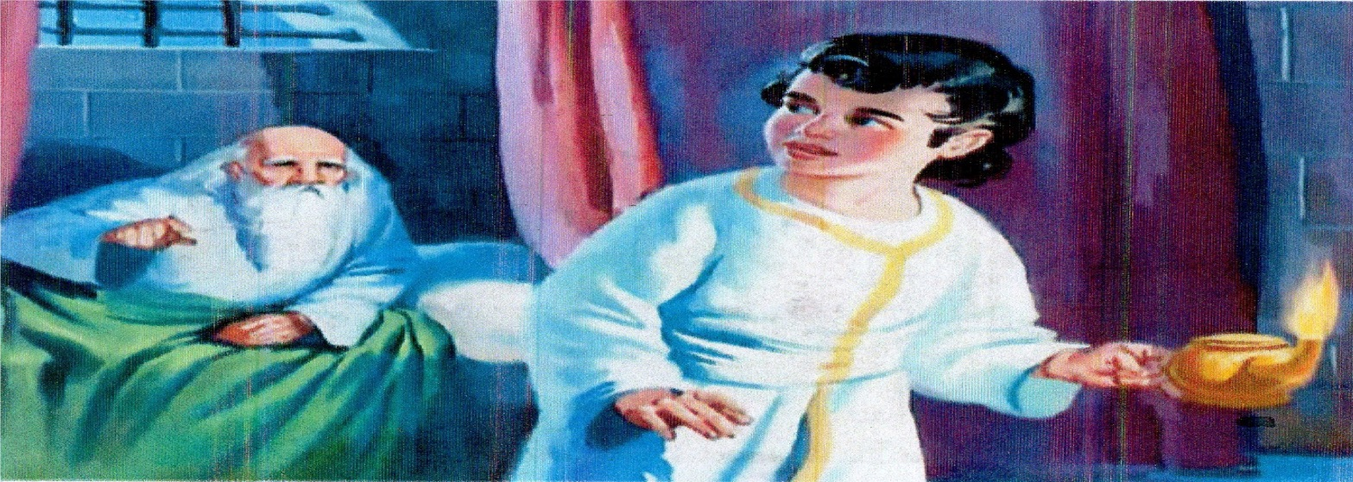
When Samuel was born, her mother Hannah took him to the temple as she had promised God.
One night, Samuel heard a voice and thought Eli the priest was calling him but it was God’s voice.
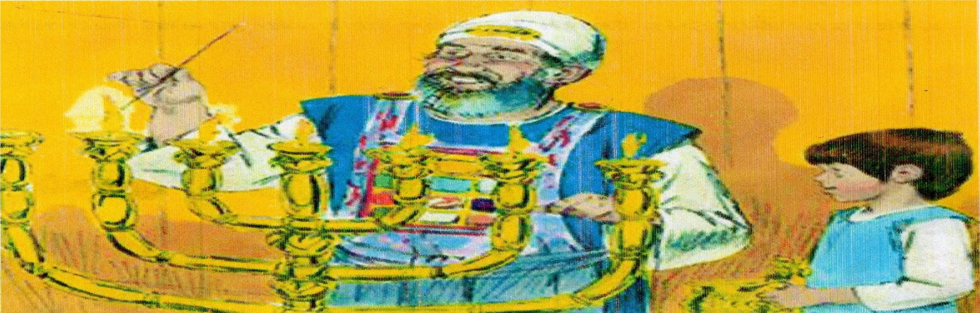Later, Samuel answered to the voice: speak thy servant listens. God then told him of what he was about to do in Israel.
Samuel later became a Prophet in the land of Israel. 1 Samuel 1:1-28, 1 Samuel 3:4-14
DAVID AND GOLIATH
Lesson: Simple faith in God can do great wonders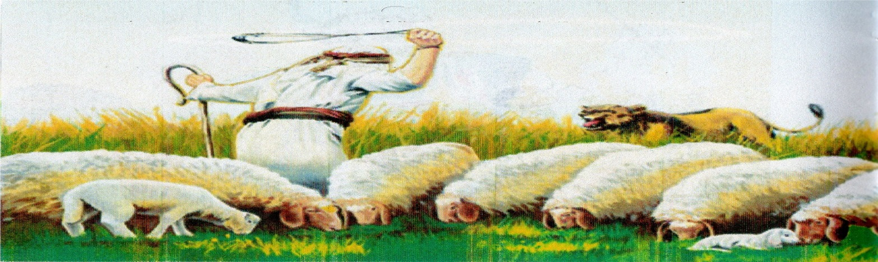
David was a young shepherd boy. He kept his father’s sheep.
One day Israel went to battle against philistines. David offered to confront huge Goliath who led philistines to battle, and was heavily armed.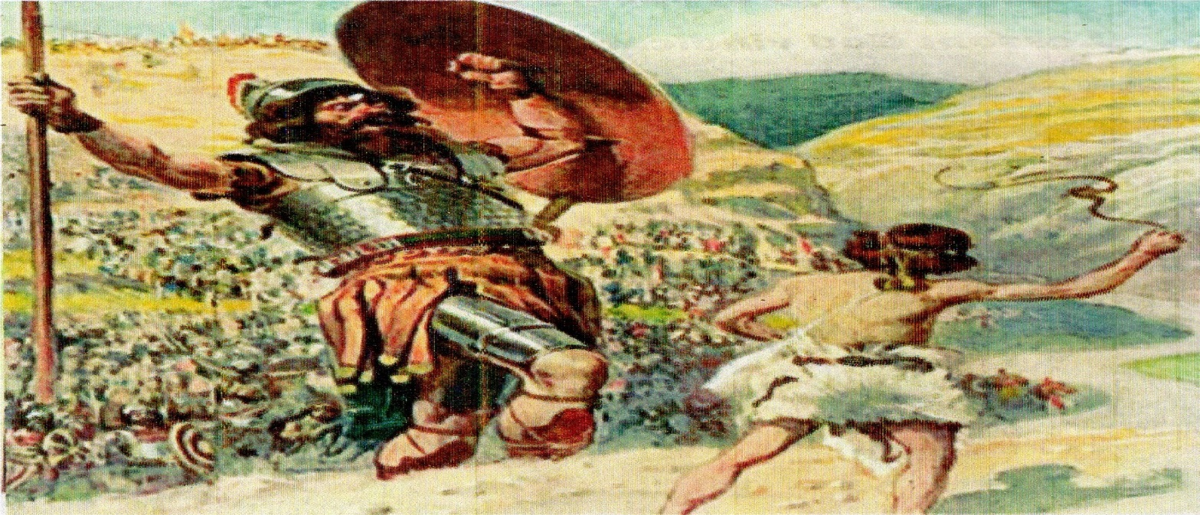
David faced the glint Goliath in the name of God of Israel. He hit his forehead with only one stone, using his sling and Goliath died instantly. The philistines fled and feared the God of Israel.
David later became a great king in Israel. 1 Samuel 17:1-52
ELIJAH AND THE PROPHETS OF BAAL.
Lesson: God vindicates his true servants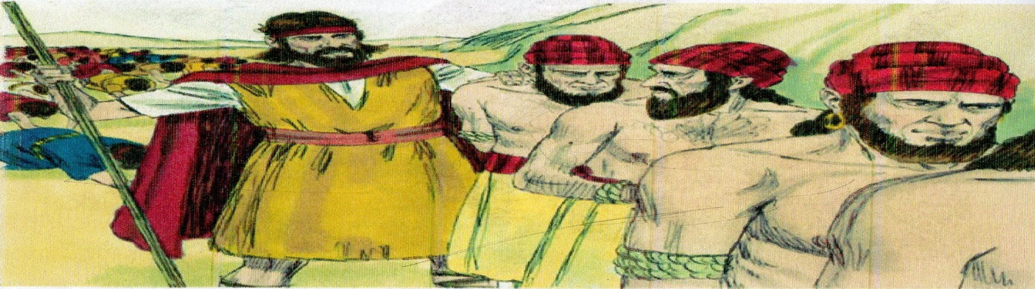
In the days of King Ahab, Elijah was the only true prophet of God in Israel.
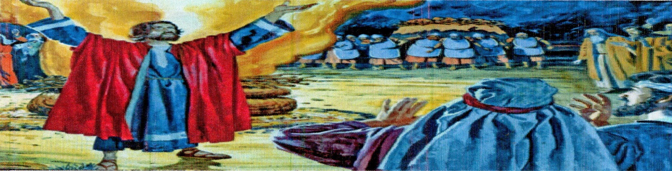Elijah chilled the prophet of Baal to call on their gods to answer with fire but they didn’t. Then Elijah repaired the altar and asked God for fire, the Lord sent down fire and confirmed that Elijah was his only prophet. 1 Kings 18:19-39
QUEEN ESTTHER
Lesson: We can be in a certain position at a tie for a purpose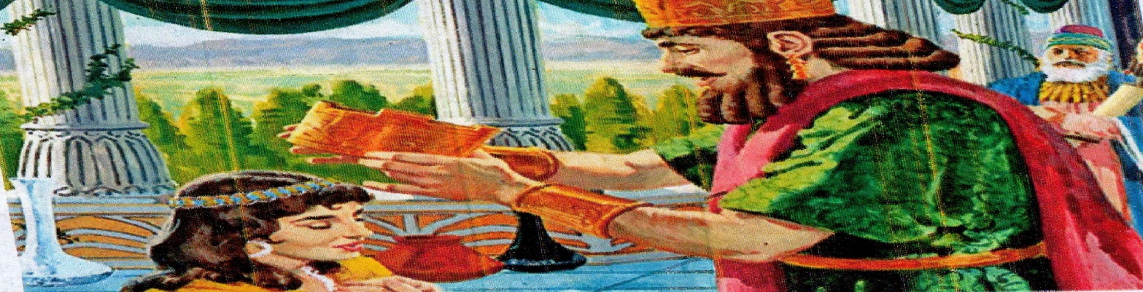
Esther the Jew got married to the king of Persia
The Persians hated Jews and wanted them killed.
Esther pleaded with the king to save her people. The king hearkened to Esther and the Jews were not hurt. Esther 1:9
THE SUFFERING OF JOB
Lesson: God can test our faithfulness through sufferings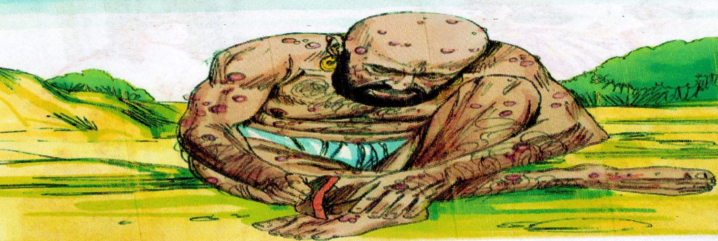
There was a man in the land of UZ, his name was job.
That man was perfect and upright, and one that feared God, and shunned evil.
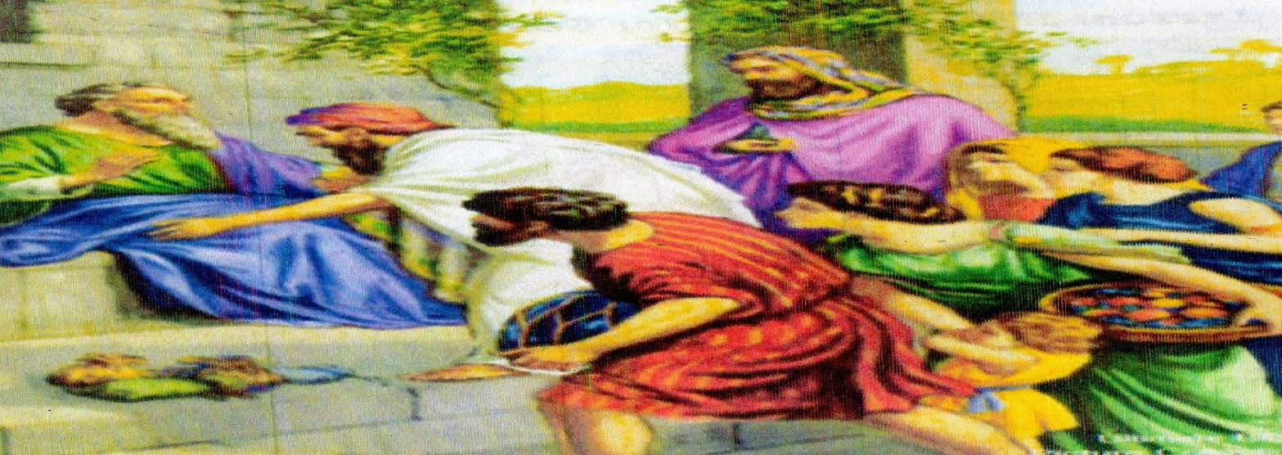Satan was sent to tempt Job’s faith in God. All his children, properties and health were destroyed but he stayed faithful to God.
After job had passed the test, God restored all what Satan had taken from him and he lived happily. Job
THE FIERY FURNACE
Lesson: if we can stand for God, he can also stand for us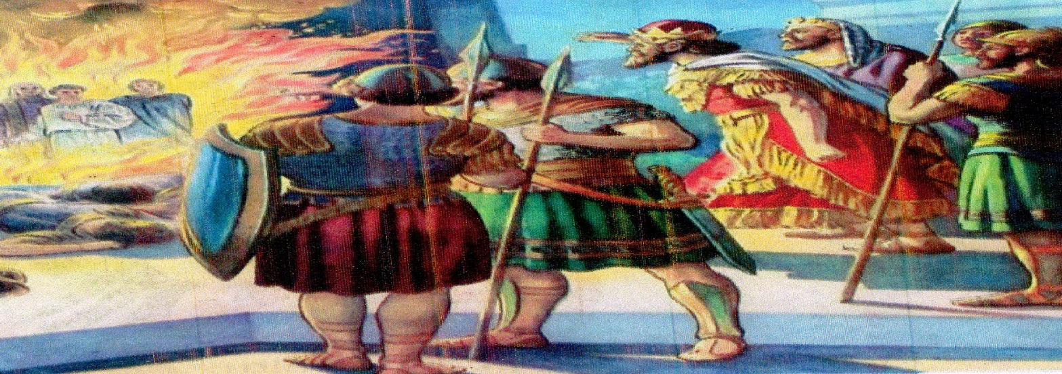
Meshach, shadrack and Abednego refused to bow down before king Nebuchadnezzar’s golden statue. They were thrown into the fiery furnace.
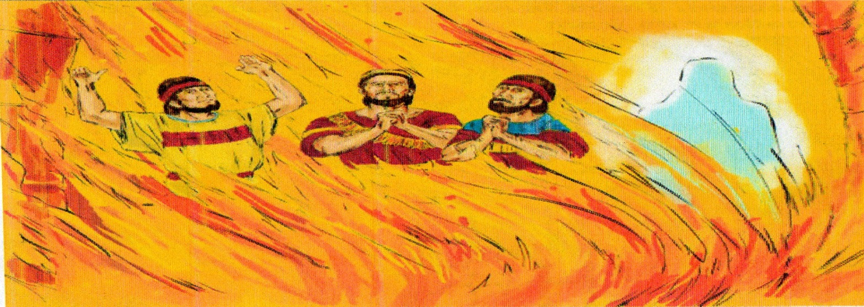The Lord came down himself and was with them as the fourth man, in the big fire.
He delivered them from the fire unhurt. Daniel 3
DANIEL IN THE LION’S DEN
Lesson: There is no situation that God can’t deliver us from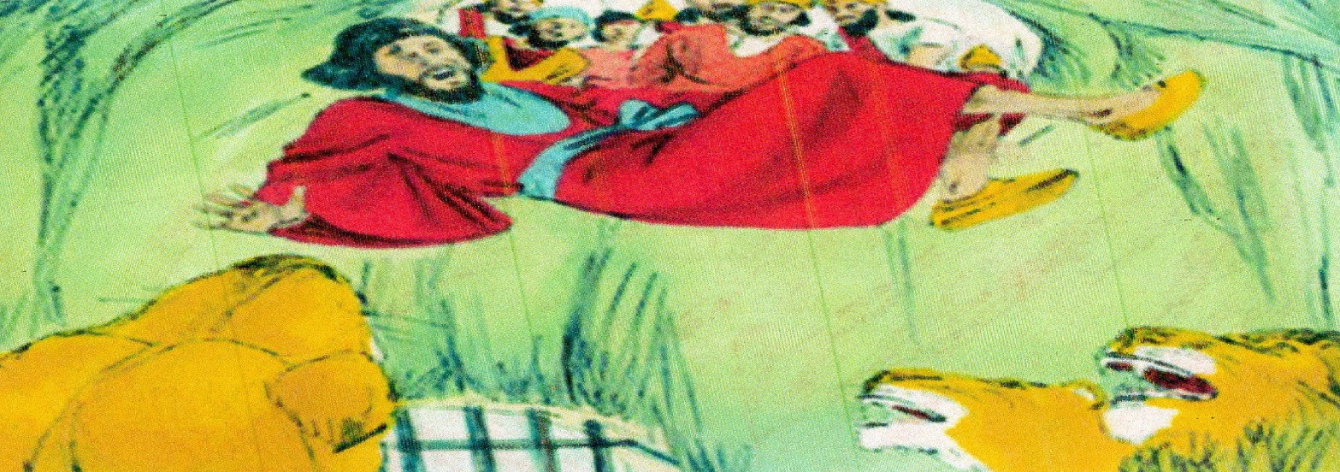
Daniel was thrown into the den of lions because he couldn’t stop praying his God despite a warning from the king.
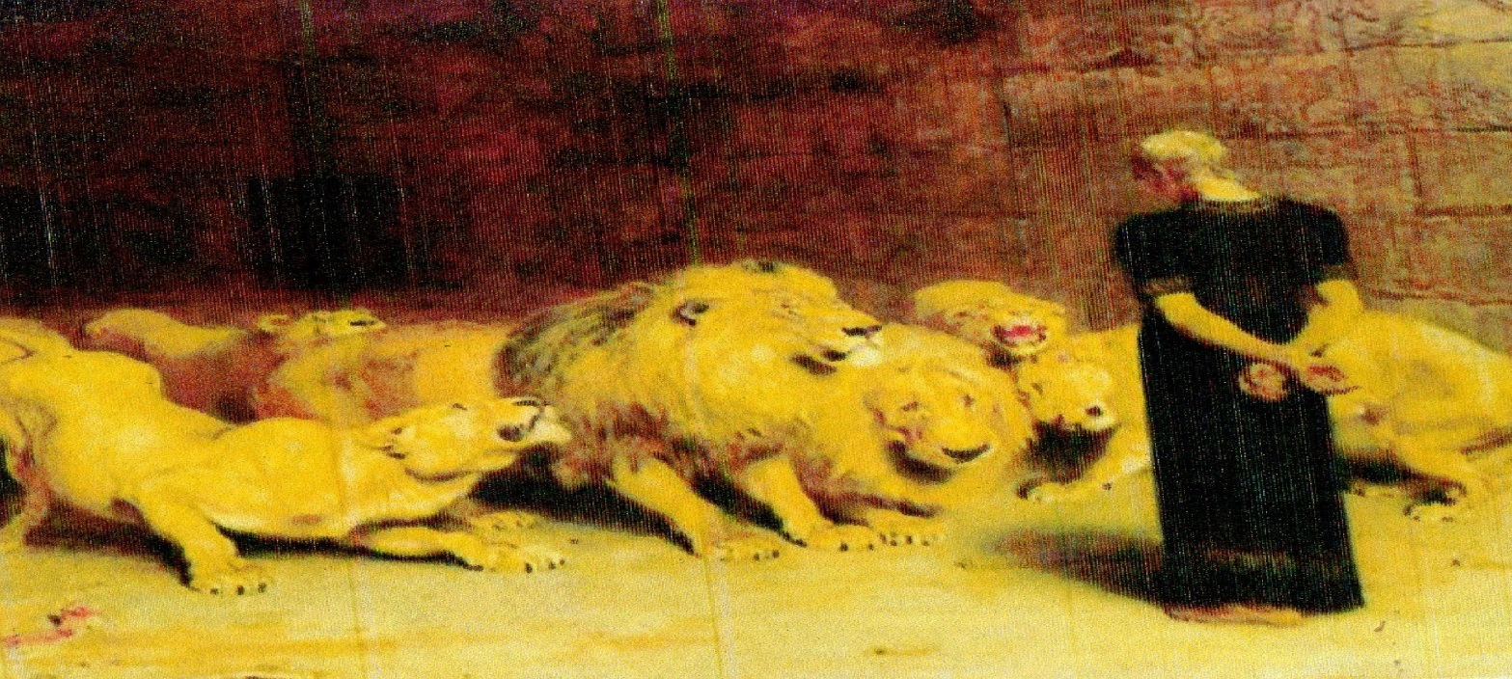However, when he was thrown into the. He sent his angel who shut the mouth of lions and he wasn’t hurt. The king was surprised and acknowledged the God of Daniel. Daniel 2:1-28
JONAH AND THE WHALE
Lesson: We cannot hide from God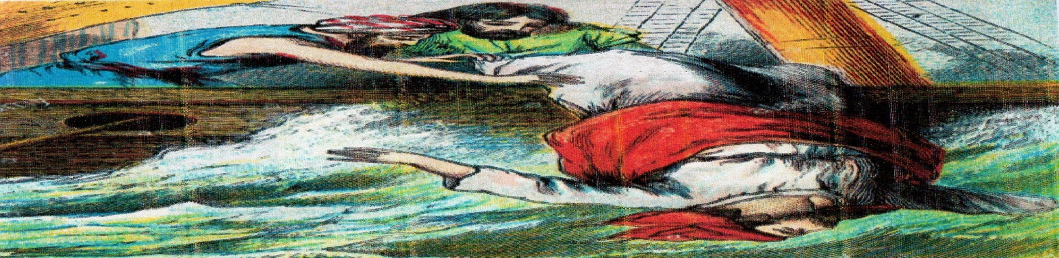
Jonah was sent by God to go and preach in a city called Nineveh. He however took a ship to Tar shish for he didn’t want to go where God had sent him.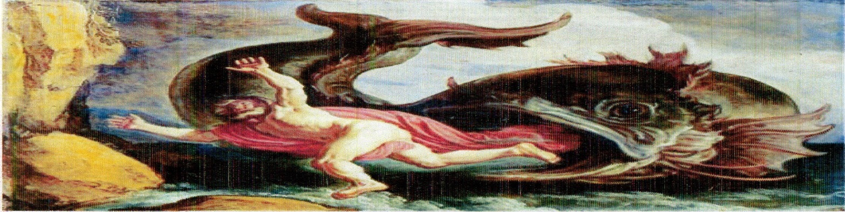
God then sent a great wind in the sea and the ship almost capsized. He was thrown into the sea and a big fish swallowed him and spat him on dry land. Then Jonah obeyed, went to Nineveh and delivered God’s message. Jonah 1-3
JESUS IS BORN
Lesson: God fulfills his word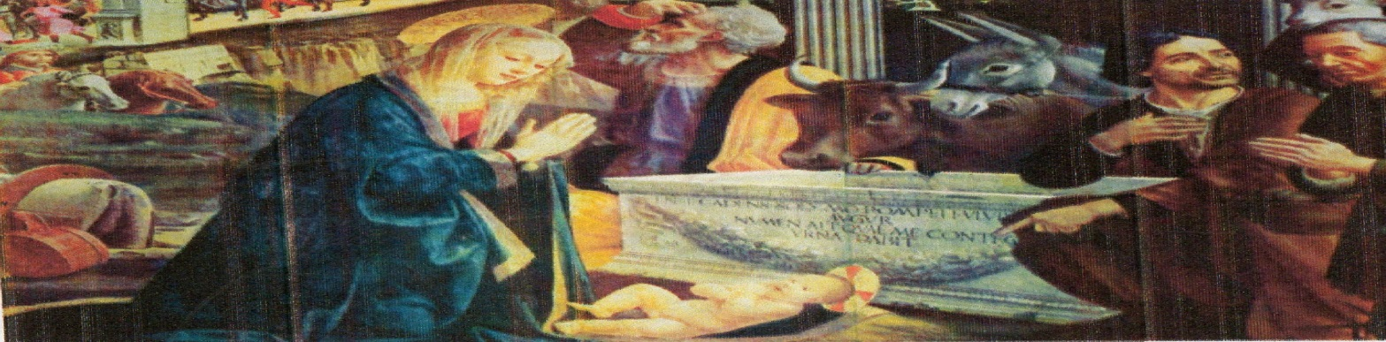
The Angel of the Lord appeared to Mary then Joseph; he told them of the supernatural birth of God’s son called Jesus.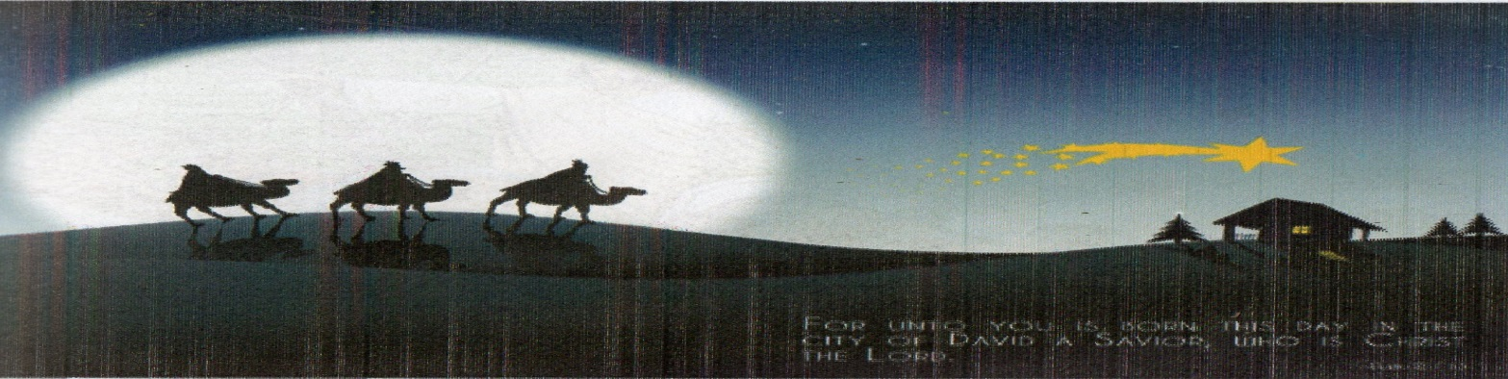
Jesus was born in Bethlehem. Three wise men followed a star and found baby Jesus. They gave him precious gifts. Mathew 1:18-25, Luke 1:26-57, Luke 2:1-7
JESUS CALMS THE STORM
Lesson: Even the nature obeys God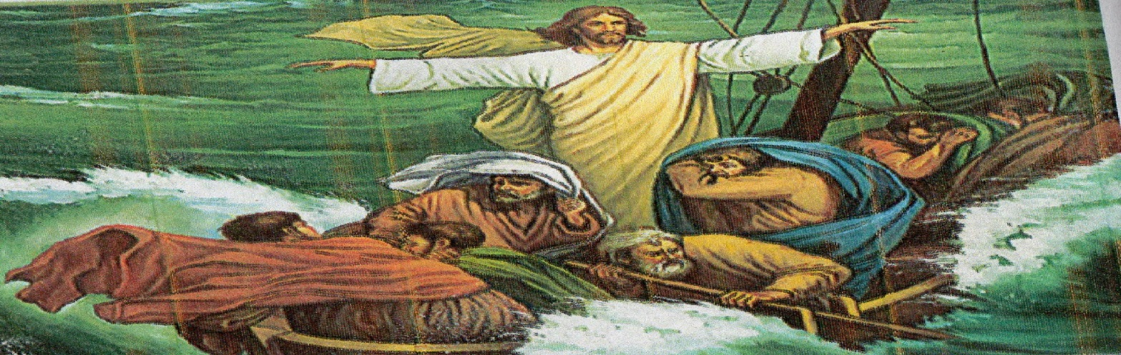
One day Jesus was sailing in a board with his disciples. There was a great storm in the sea and their boast almost overturned. 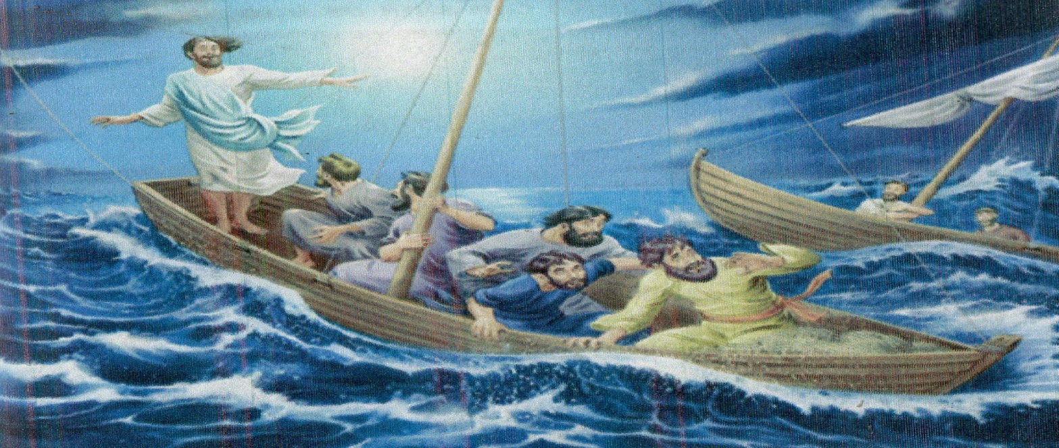
Jesus was sleeping and the disciples awakened him crying, ‘Master save us’. Jesus arose up rebuked the wind, and said unto the sea, ‘Peace be still’. And the wind ceased, and there was a great calm. Mark 4:35-41, Luke 8:22-25
PETER WALKS ON THE WATER
Lesson: Lack of faith can sink us into life’s problems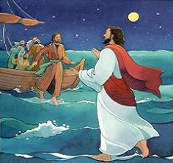
The disciples were in the boat at the sea. The they saw somebody walking on the water towards them and were greatly afraid. Jesus told them; it is I, be not afraid’.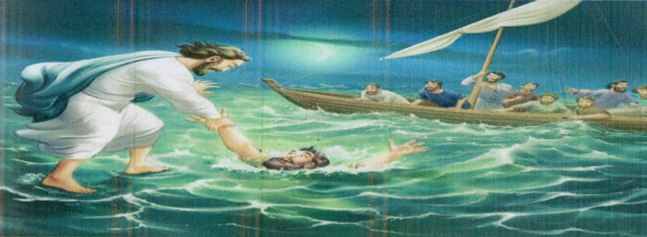 Peter walked on the water towards Jesus but when he doubted, he started to sink. Jesus saved peter and told him, ‘thou of little filth, why did you doubt?’ Mark 6:45-51, John 6:16-20
THE GOOD SAMARITAN
Lesson: we are our brothers’ keepers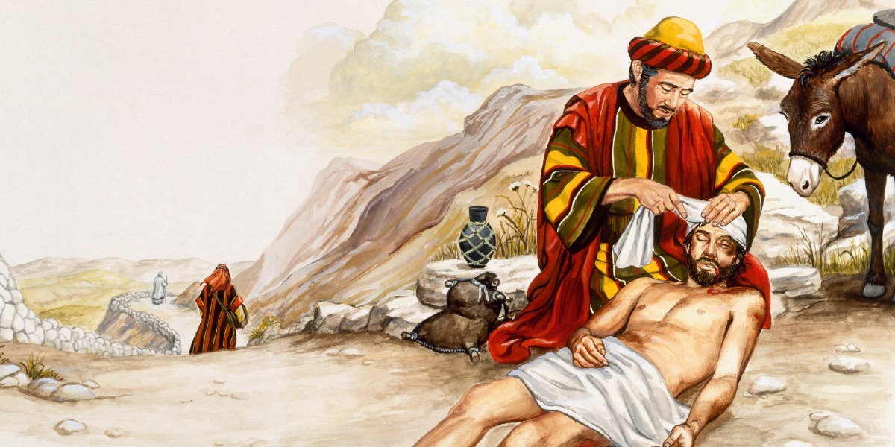
Jesus tells a parable of who a good neighbor is. A certain person had been attacked, robbed, wounded badly and left on the wayside. 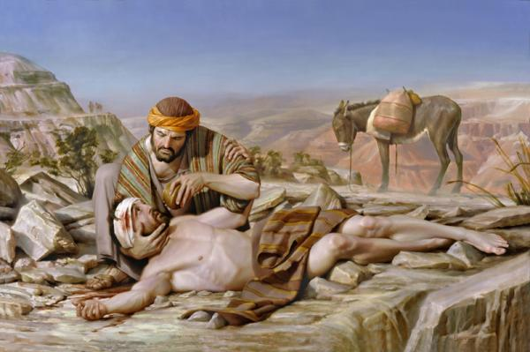A Jewish priest and a Levite passed by, saw him but didn’t help him. But a certain Samaritan saw him and was concerned. He gave him first aid and took care of him. Jesus taught us to be good Neighbors. Luke 10:29-37
THE BLIND BARTIMAEUS
Lesson: Miracles can happen if we can only believe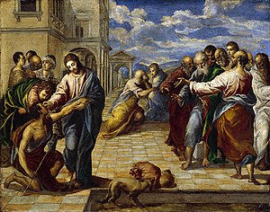
A certain blind man sat by the highway begging. When he heard the Jesus was passing his way, he cried, ’Jesus have mercy on me.’ 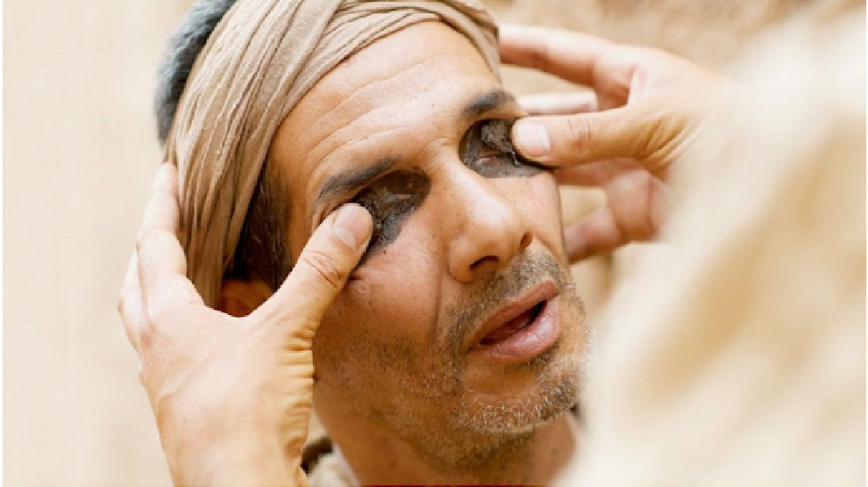
Jesus stopped and asked him what he wanted and he said that he wanted to see. Jesus said unto him, Go your way; your faith has healed you. Immediately he received his sight, and followed Jesus along the way. Mark 10:46-52
THE STORY OF PRODIGAL SON
Lesson: God’s great love and Grace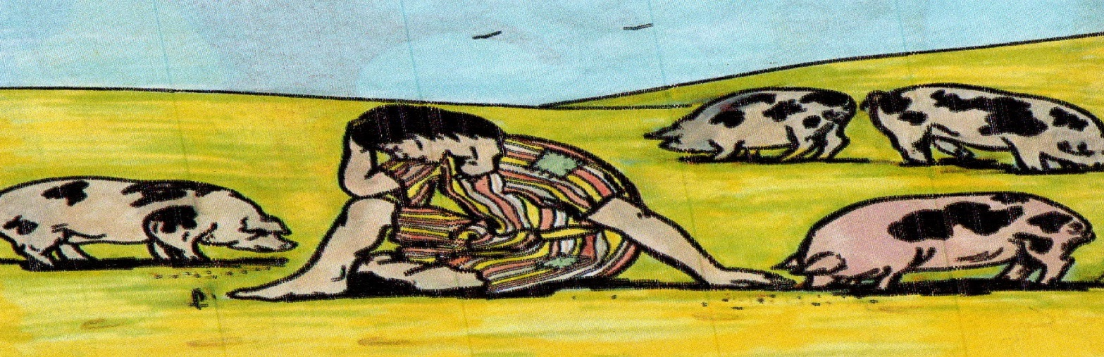
Jesus told a parable of a man who had two sons. The younger demanded inheritance from given went to a far country and spent everything wastefully.
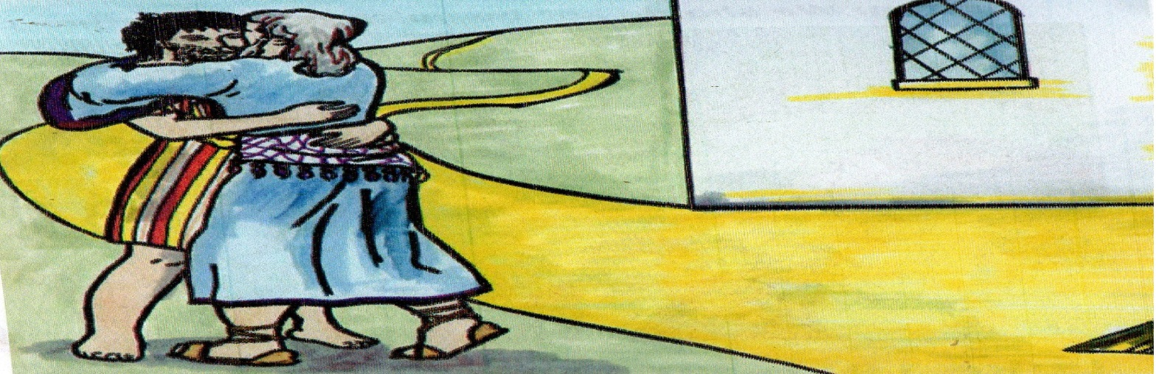He suffered in much poverty until he decided to go back to his father and ask for forgiveness. His father received him with great joy and forgave him. Luke 15:11-32
ZACCHAEUS THE SHORT MAN
Lesson: We should not quick to judge other people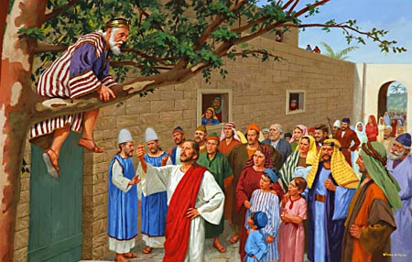
Zacchaeus was tax Collectors. One day Jericho and Zacchaeus being a short man climbed a sycamore tree to see Jesus as he passed. 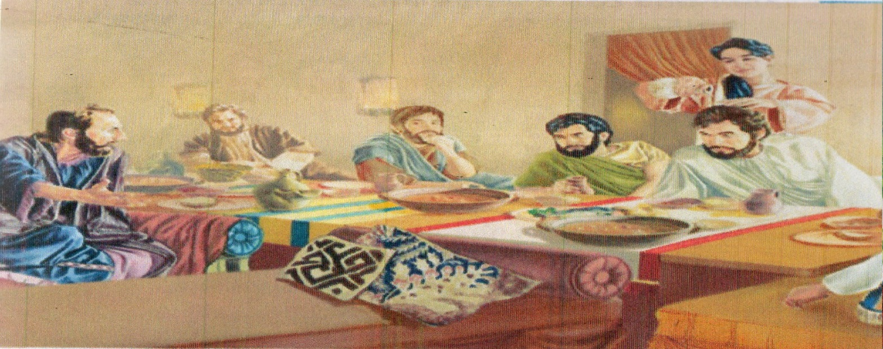
When Jesus reached where Zacchaeus was, he told him to come down and he visited him in his house. Jesus showed him his love, even though many people saw him as a sinner. Luke 19:1-10
JESUS TURNS WATER INTO WINE
Lesson: God can change any circumstance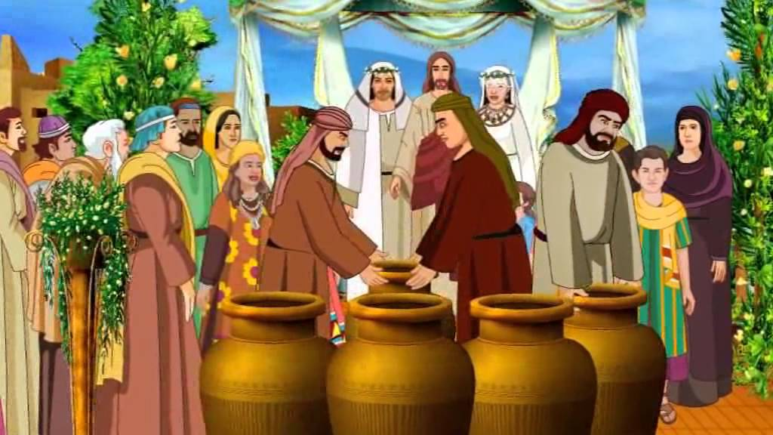
There was a certain wedding at Cana of Galilee. Jesus and his disciples were invited. His mother too was in attendance. The wine ran out Jesus was informed. 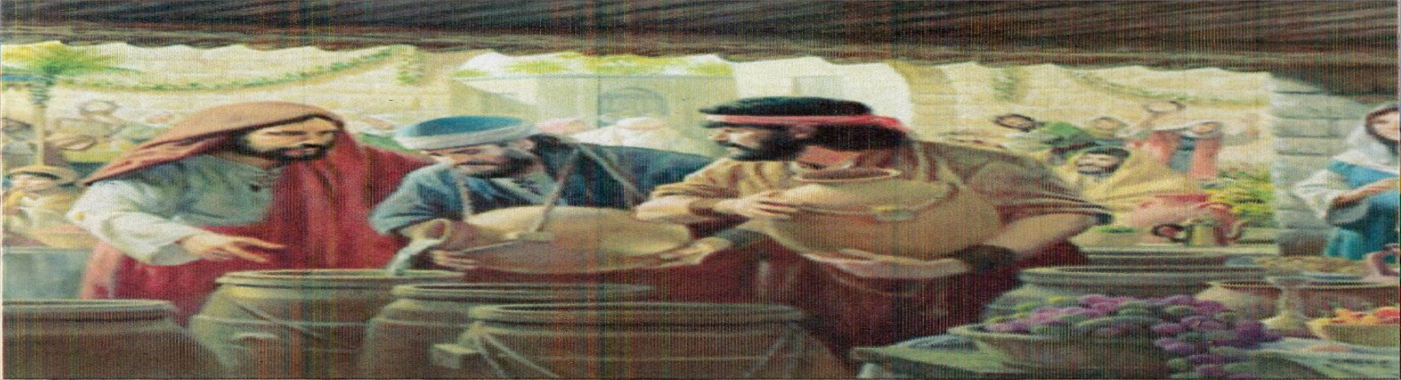
Jesus said unto them, fills six water pots with water. He blessed the water and it miraculously turned into sweet wine. This was the first miracle that Jesus performed. John 2:1-11
JESUS RAISES LAZARUS FROM DEAD
Lesson: God has power over death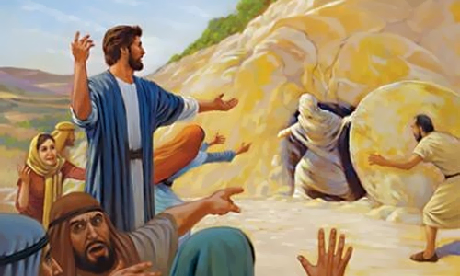
There was a certain man in the town of Bethany who was a great friend of Jesus, his name was Lazarus. Lazarus got sick and died. When Jesus to their home, Jesus wept, he then went to his grave and cried with a loud voice, ‘Lazarus, come forth’. 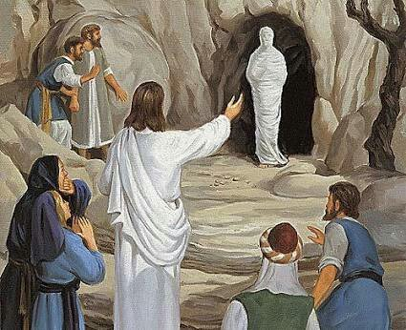
Lazarus resurrected and all people present witnessed the glory of God. John 11:1-45
THE LAST SUPPER
Lesson: we ought to share to share and submit to one another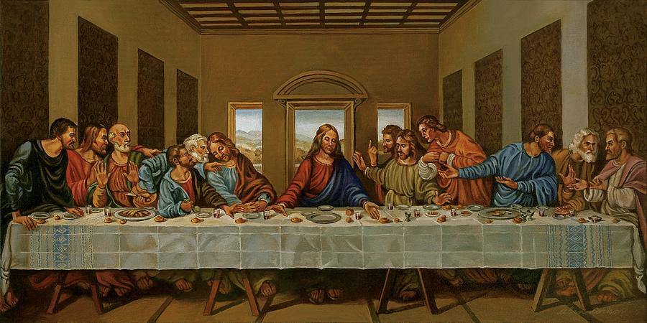
Jesus knowing that his hour of suffering had com, he sat down with his disciples for the last supper.
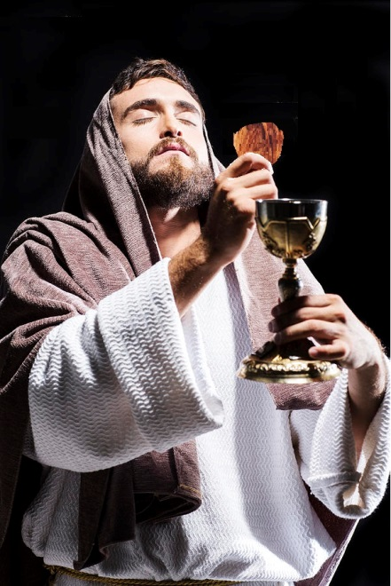
As they communed the last supper, Jesus told them that his hour for tribulation had come. He urged them to be taking the Lord’s Supper as a way of remembering him when he is gone. Luke 22:14-20
JESUS DIED ON THE CROSS
Lesson: Jesus died on the cross so that we could saved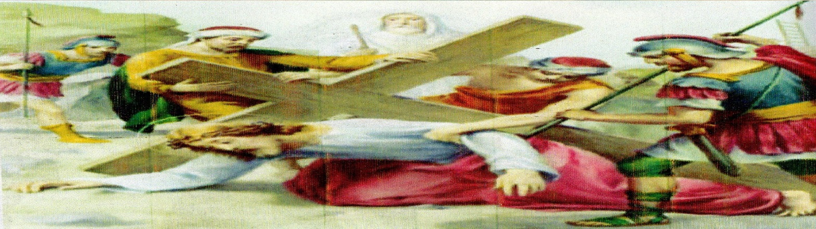
Even after all the good things and miracles that Jesus had done, religious and political leaders hated him and didn’t believe that he was the Son of God.
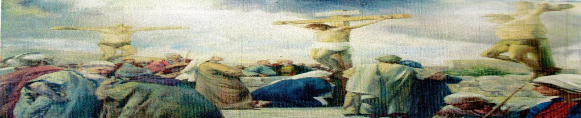They gave authority for him to be killed. Jesus was crucified at a place called Golgotha.
Jesus died for sinners.
You can now be saved by accepting Jesus Christ as your personal savior. Mark 15: 1-39
JESUS RESURRECTS AND LIVES FOREVERMORE
Lesson: Those who dies in Christ shall surely live again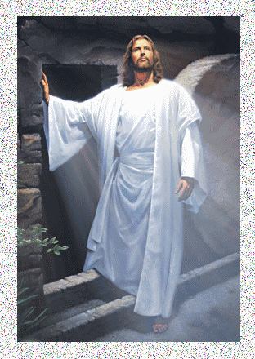
The grave couldn’t hold Jesus for more than three days! He conquered them. He them ascended to heaven after commissioning his disciples. 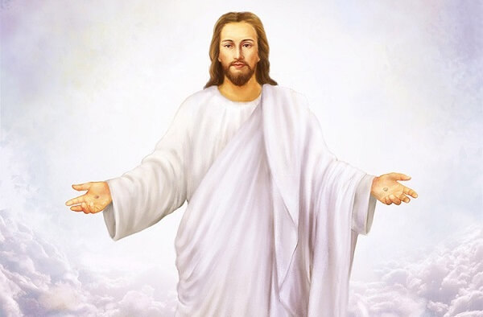
He now sits at the right hand of God with full authority and power over everything in heaven and the Earth. AMEN. Mark 16:1-20
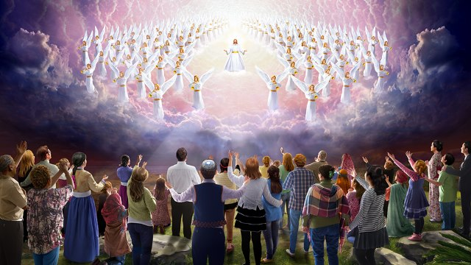"Look, he is coming with the clouds," and "every eye will see him, even those who pierced him"; and all peoples on earth "will mourn because of him." So shall it be! Amen. Revelation 1:7
And it will be said in that day: “Behold, this is our God; We have waited for Him, and He will save us. This is the Lord; We have waited for Him; We will be glad and rejoice in His salvation.” Isaiah 25:9
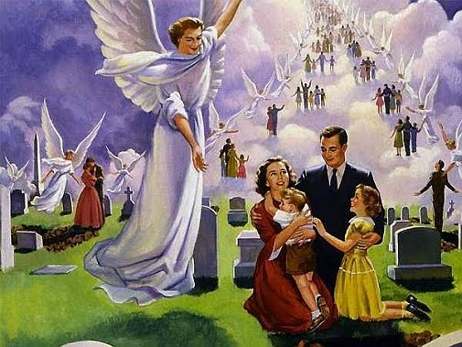The Resurrection of Jesus Christ
15 Now I would remind you, brothers,1 of the gospel I preached to you, which you received, in which you stand, 2 and by which you are being saved, if you hold fast to the word I preached to you—unless you believed in vain. 3 For I delivered to you as of first importance what I also received: that Christ died for our sins in accordance with the Scriptures, 4 that he was buried, that he was raised on the third day pin accordance with the Scriptures, 5 and that he appeared to Cephas, then to the twelve. 6 Then he appeared to more than five hundred brothers at one time, most of whom are still alive, though some have fallen asleep. 7 Then he appeared to James, then to all the apostles. 8 Last of all, as to one untimely born, he appeared also to me. 9 For I am the least of the apostles, unworthy to be called an apostle, because I persecuted the church of God. 10 But by the grace of God I am what I am, and his grace toward me was not in vain. On the contrary, I worked harder than any of them, though it was not I, but the grace of God that is with me. 11 Whether then it was I or they, so we preach and so you believed.
The Resurrection of the Dead
12 Now if Christ is proclaimed as raised from the dead, how can some of you say that there is no resurrection of the dead? 13 But if there is no resurrection of the dead, then not even Christ has been raised. 14 And if Christ has not been raised, then our preaching is in vain and your faith is in vain. 15 We are even found to be misrepresenting God, because we testified about God that he raised Christ, whom he did not raise if it is true that the dead are not raised. 16 For if the dead are not raised, not even Christ has been raised. 17 And if Christ has not been raised, your faith is futile and you are still in your sins. 18 Then those also who have fallen asleep in Christ have perished. 19 If in Christ we have hope2 in this life only, ewe are of all people most to be pitied. 20 But in fact Christ has been raised from the dead, the first fruits of those who have fallen asleep. 21 For as by a man came death, iby a man has come also the resurrection of the dead. 22 For as in Adam all die, so also in Christ shall all be made alive. 23 But each in his own order: Christ the first fruits, then at his coming those who belong to Christ. 24 Then comes the end, when he delivers the kingdom to God the Father after destroying every rule and every authority and power. 25 For he must reign until he has put all his enemies under his feet. 26 The last enemy to be destroyed is death. 27 For q“God3 has put all things in subjection under his feet.” But when it says, “all things are put in subjection,” it is plain that he is excepted who put all things in subjection under him. 28 When all things are subjected to him, then the Son himself will also be subjected to him who put all things in subjection under him, that God may be all in all. 29 Otherwise, what do people mean by being baptized on behalf of the dead? If the dead are not raised at all, why are people baptized on their behalf? 30 Why are we tin danger every hour? 31 I protest, brothers, by my pride in you, which I have in Christ Jesus our Lord, I die every day! 32 What do I gain if, humanly speaking, wI fought with beasts at Ephesus? If the dead are not raised, “Let us eat and drink, for tomorrow we die.” 33 Do not be deceived: “Bad company ruins good morals.”4 34 Wake up from your drunken stupor, as is right, and do not go on sinning. For some have no knowledge of God. I say this to your shame.
The Resurrection Body
35 But someone will ask, “How are the dead raised? With what kind of body do they come?” 36 You foolish person! What you sow does not come to life unless it dies. 37 And what you sow is not the body that is to be, but a bare kernel, perhaps of wheat or of some other grain. 38 But God gives it a body as he has chosen, and to each kind of seed its own body. 39 For not all flesh is the same, but there is one kind for humans, another for animals, another for birds, and another for fish. 40 There are heavenly bodies and earthly bodies, but the glory of the heavenly is of one kind, and the glory of the earthly is of another. 41 There is one glory of the sun, and another glory of the moon, and another glory of the stars; for star differs from star in glory. 42 So is it with the resurrection of the dead. What is sown is perishable; what is raised is imperishable. 43 It is sown in dishonor; it is raised in glory. It is sown in weakness; it is raised in power. 44 It is sown a natural body; it is raised a spiritual body. If there is a natural body, there is also a spiritual body. 45 Thus it is written, “The first man Adam became a living being”;5 the last Adam became a life-giving spirit. 46 But it is not the spiritual that is first but the natural, and then the spiritual. 47 The first man was from the earth, la man of dust; the second man is from heaven. 48 As was the man of dust, so also are those who are of the dust, and as is the man of heaven, so also are those who are of heaven. 49 Just as we have borne the image of the man of dust, we shall6 also bear the image of the man of heaven.
Mystery and Victory
50 I tell you this, brothers: flesh and blood cannot inherit the kingdom of God, nor does the perishable inherit the imperishable. 51 Behold! I tell you a mystery. We shall not all sleep, but we shall all be changed, 52 in a moment, in the twinkling of an eye, at the last trumpet. For the trumpet will sound, and the dead will be raised imperishable, and we shall be changed. 53 For this perishable body must put on the imperishable, and this mortal body must put on immortality. 54 When the perishable puts on the imperishable, and the mortal puts on immortality, then shall come to pass the saying that is written: death is swallowed up in victory.” 55 “O death, where is your victory?
O death, where is your sting?”
56 The sting of death is sin, and the power of sin is the law. 57 But thanks be to God, who gives us the victory through our Lord Jesus Christ. 58 Therefore, my beloved brothers, be steadfast, immovable, always abounding in the work of the Lord, knowing that in the Lord your labor is not in vain. 1 Corinthians 15:1–58

The Holy Seed Church
Neema Evangelism Centre
Global Healing Ministries
P.O Box 1266 – 00521 Embakasi – Kenya
Email: apostlesimiyu@gmail.com
Website: www.theholyseedchurch.org
Contact Us: +254/721141544 / +254/714268947
Copyright 2019

